# Media Analysis - No need to demonize ChatGPT but AI regulation is a must _ Arab News

## Short Summary

The article discusses the potential impact of ChatGPT, a powerful language processing AI developed by OpenAI, on various industries including journalism, education, and healthcare, while emphasizing the need for regulation to prevent possible negative effects such as plagiarism, lack of originality, job displacement, and ethical concerns.

## Summary

1. ChatGPT, a powerful language model developed by OpenAI, has the ability to understand and respond to natural language, making it a valuable asset across various industries including journalism.  
2. The rapid adoption of ChatGPT has led to concerns over academic integrity in education due to its potential for generating essays and reports quickly, prompting universities and schools to adjust their instruction methods and testing procedures.  
3. In the field of journalism, there are fears that AI-generated content could replace human journalists, though some news outlets have used it experimentally with mixed results.  
4. Despite the potential threats posed by AI advancements like ChatGPT, Dr. Amal Mudallali suggests that regulations are necessary to prevent AI from overwhelming human work and tipping the balance in its favor.

## Question 1

The media framing of the public discussion about ChatGPT in the analyzed text emphasizes both the potential benefits and threats it poses to various industries, particularly education, journalism, and healthcare. Metaphors used to describe ChatGPT include a great opportunity for the advancement of the human race opportunity , an existential threat to human work threat , and a great equalizer benefit . The text also highlights the concept of a watershed historical moment, suggesting a significant turning point in technological development. In terms of the role of ChatGPT, it is often referred to as a powerful tool or bot that can generate various forms of written content with remarkable speed and efficiency.

## Question 2

In the provided text, the following perspectives and aspects of the topic ChatGPT are being widely covered 1. The capabilities and potential impact of ChatGPT on various industries, particularly journalism and education. 2. Concerns regarding the role of AI in education, cheating, and plagiarism. 3. Fears about AI replacing human work, especially in journalism, medicine, and literature. 4. Potential ethical issues and copyright protection regarding AI-generated content. 5. The limitations of ChatGPT and its imperfections. 6. The debate on whether AI could prove to be a great equalizer for the developing world. 7. The need for regulations in AI technology to prevent negative consequences. Aspects that are not explicitly covered but can be inferred include 1. The technical details of how ChatGPT works, such as its architecture and training methods. 2. Economic implications of widespread AI use on job markets. 3. Privacy and security concerns related to the collection and processing of data by AI systems. 4. Long-term societal changes resulting from increased AI integration in everyday life. 5. The potential positive impact of AI on various industries beyond journalism and education, such as finance or manufacturing. 6. Any efforts towards international cooperation or collaboration in regulating AI technology.

## Question 3

Not mentioned. The article discusses the impact of AI, particularly ChatGPT, but it does not specify how the Arabic world leverages or interacts with this technology.

## Question 4

The article suggests that while AI, specifically ChatGPT, has immense potential to revolutionize various sectors like journalism and education, it also poses challenges such as plagiarism and job displacement. The final message emphasizes the need for regulations to ensure a balanced development of AI technology, preventing it from causing harm to human work and opportunities.

## Sentiment

The sentiment is 3.0

## Entities

Disclaimer Views, Generative Pretrained Transformer, Google, READ Learning, OpenAI, The Washington Post, CNET, Post, The New York Times, Springboard, Arab News, AI, BBC, Midjourney, Amal Mudallali, fed

## Highlights

#7cc867#fb5b89#c885da#f9cd59

## Wordcloud for #7cc867 Highlights

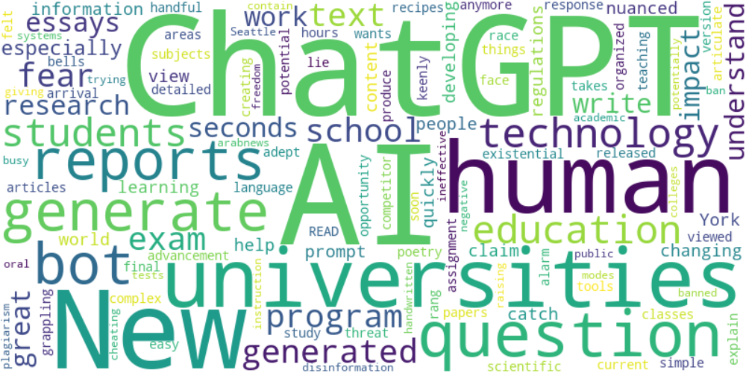

Top 10 words:

- ChatGPT: 9

- AI: 9

- human: 4

- reports: 3

- generate: 3

- bot: 3

- technology: 3

- education: 3

- universities: 3

- generated: 3

## Wordcloud for #fb5b89 Highlights

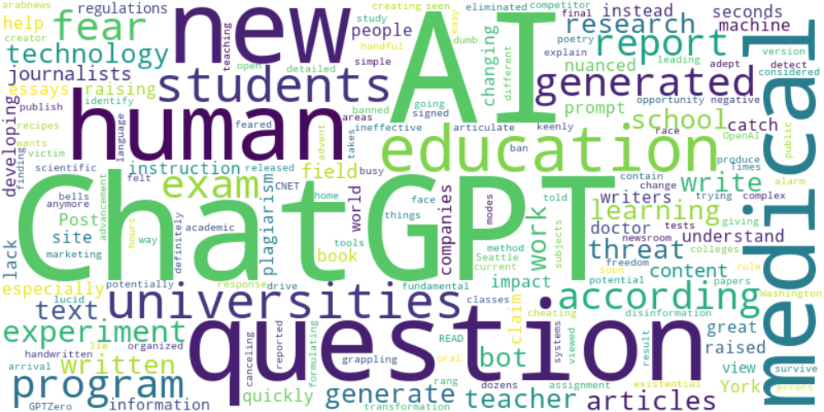

Top 10 words:

- AI: 18

- ChatGPT: 16

- human: 5

- education: 4

- question: 4

- generated: 4

- fear: 4

- questions: 4

- experiment: 4

- medical: 4

## Wordcloud for #c885da Highlights

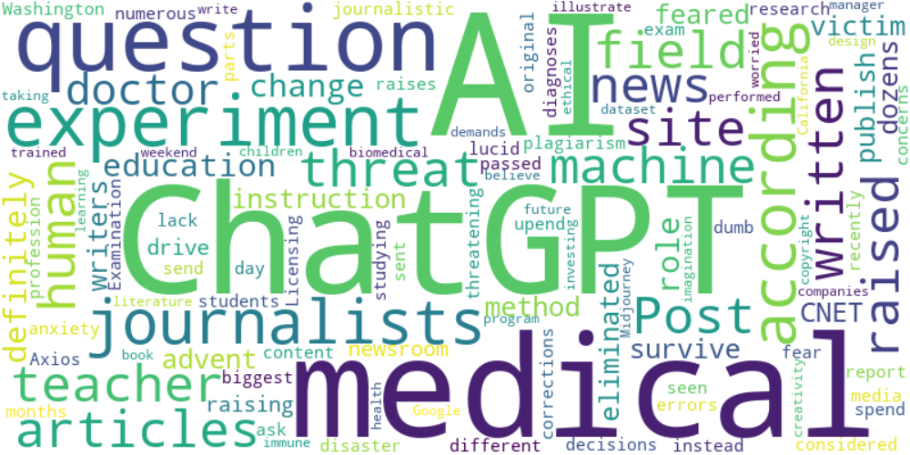

Top 10 words:

- AI: 9

- ChatGPT: 7

- experiment: 4

- medical: 4

- question: 3

- journalists: 3

- news: 2

- site: 2

- articles: 2

- according: 2

## Wordcloud for #f9cd59 Highlights

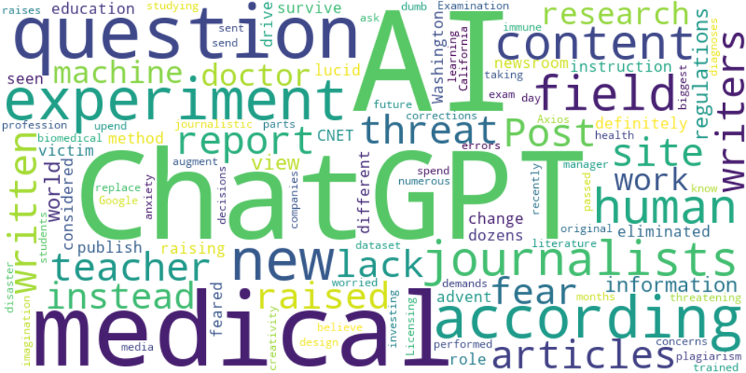

Top 10 words:

- AI: 12

- ChatGPT: 9

- experiment: 4

- medical: 4

- question: 3

- journalists: 3

- content: 3

- writers: 2

- news: 2

- site: 2